**LASSO, RIDGE & ELASTIC NET REGRESSION**

**Business Problem** = ﻿﻿Perform the Lasso and Ridge Regression to 50_startups data to predict profit.

* **Name of the File: -** 50_Startups.csv
* **Size of the File: -** 2 KB
* **Data: -** 50 Observation, 5 Variable
* **Column Name: -** R&D Spend, Administration, Marketing Spend, State, Profit

**Exploratory data Analysis** =

* **Outliers: -**  Profit variable having outliers.
* **Missing Value: -** Data don’t have Missing Values
* **Normality: -** Data are near normal
* **Transformation: -**  May be Required to improve accuracy

**Scatter plot =** From below scatter plot we can say that profit and R&D have strong correlation also Marketing and profit have good correlation.

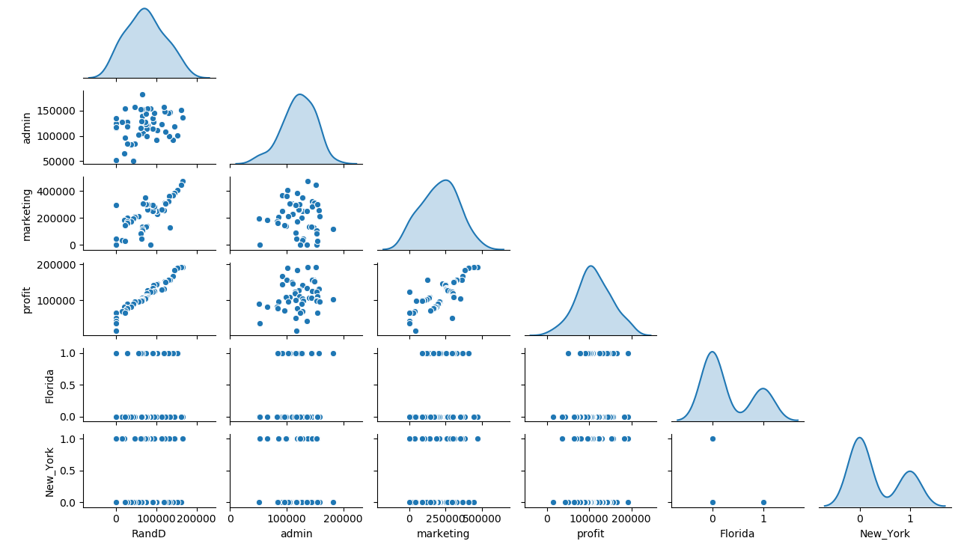

**Correlation Coefficient (r) =**  Correlation between marketing and R&D is quite high as compare to other it may causes collinearity problem.

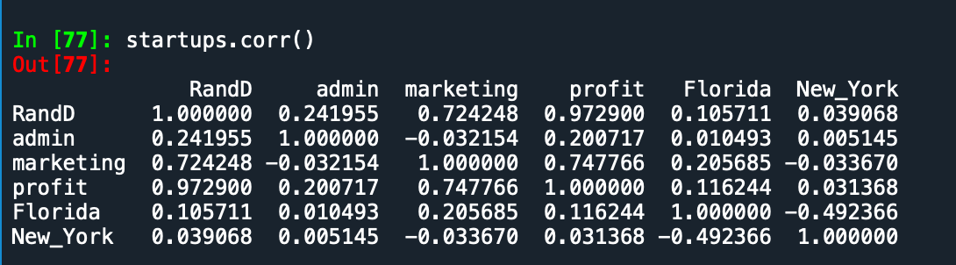

**Building Lasso Model =**

* **Scatter Plot for Selection of Perfect Lambda value : -**

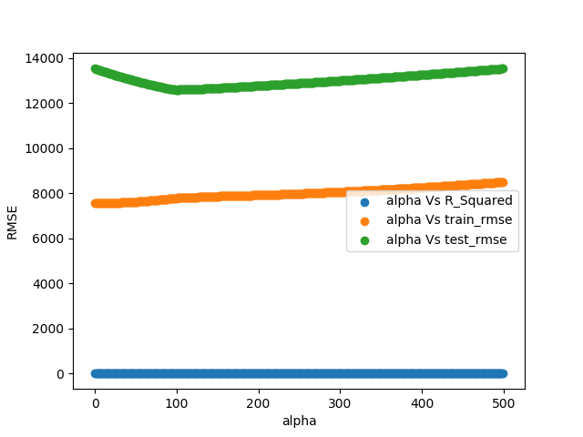

**Accuracy =** Building model by selecting optimum value of Lambda i.e. 150 by help of the above plot. Accuracy given by model as follows.

* **R2 : -** 96%
* **Train RMSE : -** 7900
* **Test RMSE :** - ﻿12660

**Important Coefficient Plot =**

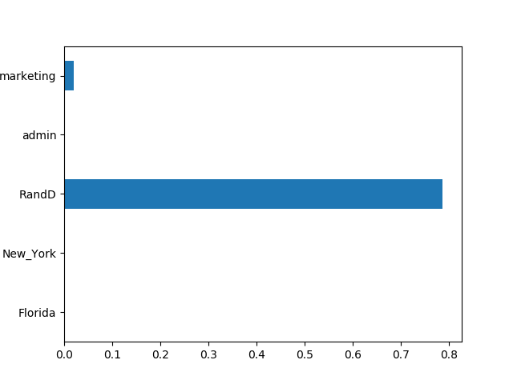

**Building Ridge Model =**

* **Scatter Plot for Selection of Perfect Lambda value : -**

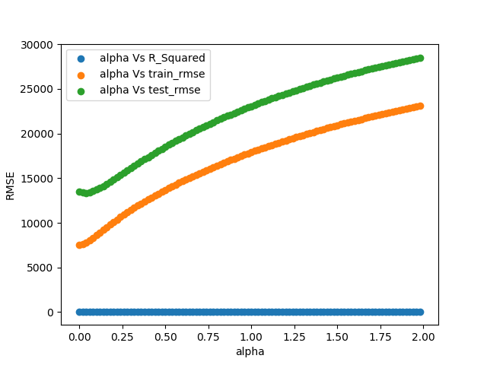

**Accuracy =** Building model by selecting optimum value of Lambda i.e. 0.01 by help of the above plot. Accuracy given by model as follows.

* **R2 : -** 96%
* **Train RMSE : -** ﻿7582
* **Test RMSE :** - ﻿13435

**Important Coefficient Plot =**

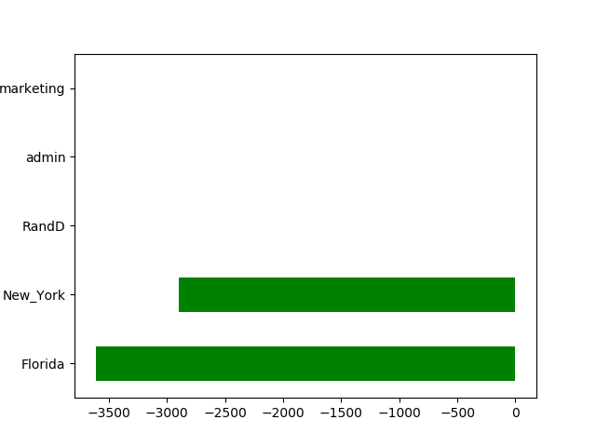

**Building Elastic Net Model =**

* **Scatter Plot for Selection of Perfect Lambda value : -**

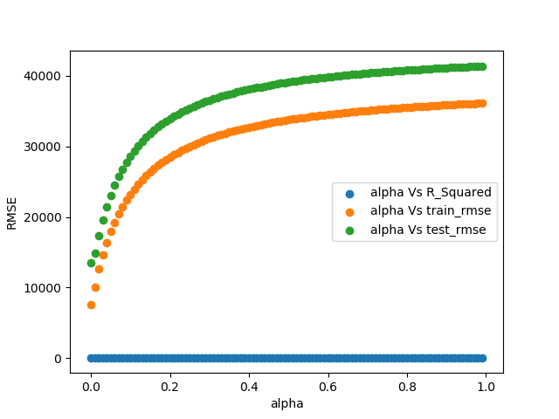

**Accuracy =** Building model by selecting optimum value of Lambda i.e. 0.01 by help of the above plot. Accuracy given by model as follows.

* **R2 : -** 93%
* **Train RMSE : -** 10090
* **Test RMSE :** - 14862

**Important Coefficient Plot =**

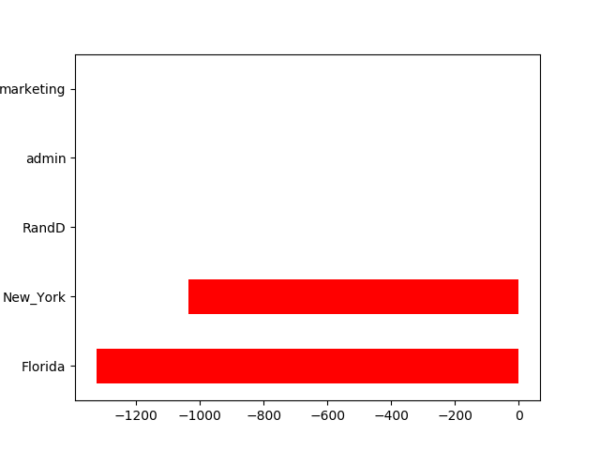

Form Above Three model Lasso is giving us best result so we can be use it for future prediction

**Python code file**: - [50 Start up Lasso and Ridge Analysis.py](https://github.com/nilaydeshmukh0/Lasso-Ridge-and-ElasticNet-Regression-With-EDA/blob/master/50%20Start%20up%20Lasso%20and%20Ridge%20Analysis/50%20Start%20up%20Lasso%20and%20Ridge%20Analysis.py)